**Purpose:** To complete what we started in class, creating a network topology with dynamic routing.

**Topology**

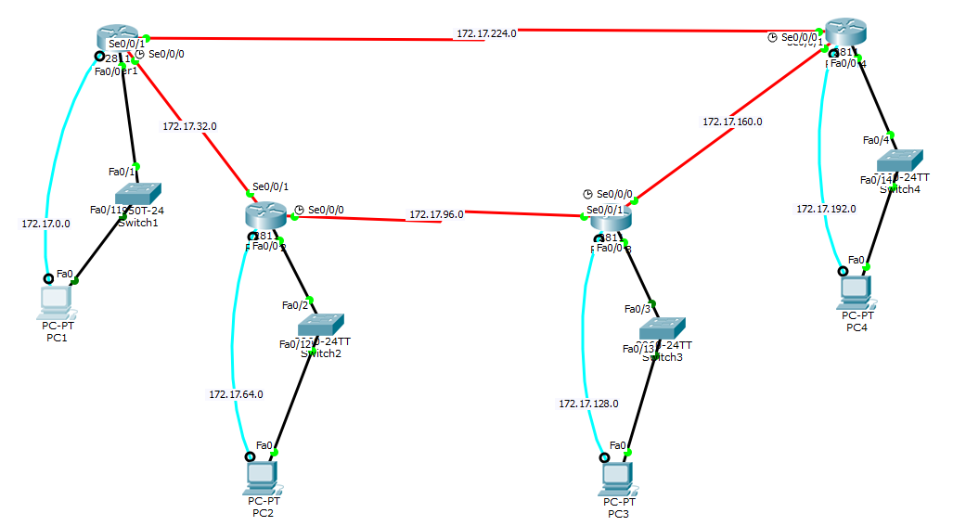

**Command Syntax**

|  |  |
| --- | --- |
| *Router rip > Version 2 > Network IP* | Configures the router to dynamically route packets using RIPv2 protocol |
| *Router ospf ID# > Network IP Wildcard Area #* | Configures the router to dynamically route packets using OSPF protocol. OSPF (1 – 65,535). Wildcard (255.255.255.255 – Subnet Mask) |
| *Show IP Protocol* | Displays the current routing protocol of the selected router. |
| *Show IP Route* | Displays the current routing table for the selected router. |

**Verification**

PC1 – Router1

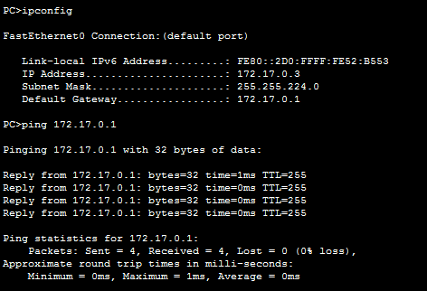

PC2 – Router2

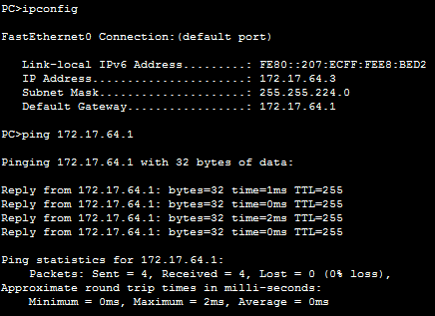

PC3 – Router3

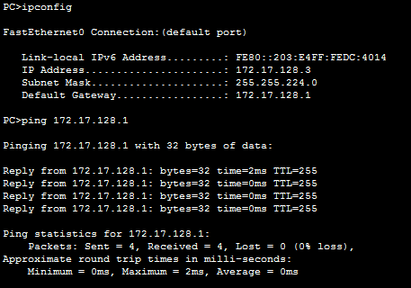

PC4 – Router4

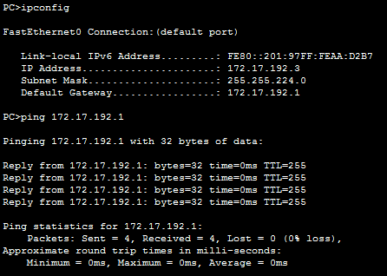

Router RIPv2 Protocol

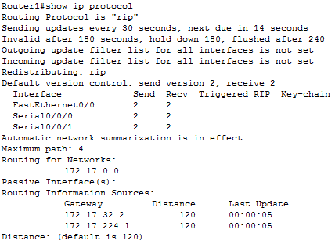

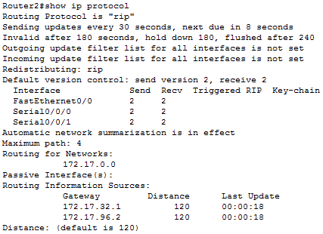

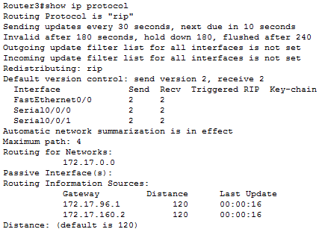

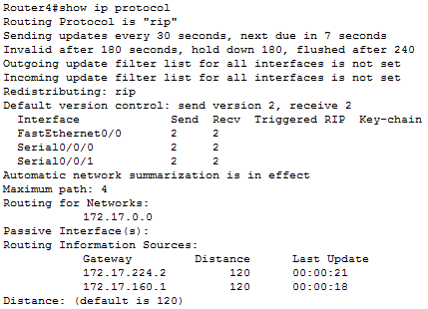

Router RIPv2 Routing Tables

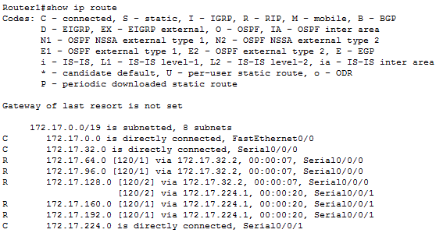

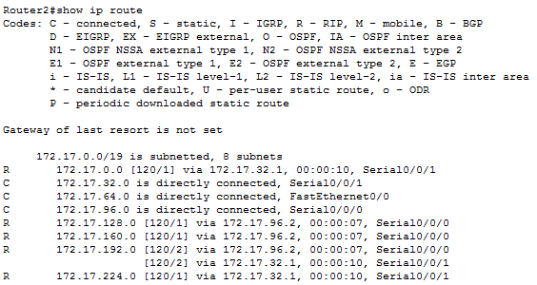

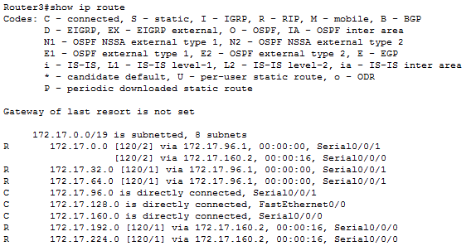

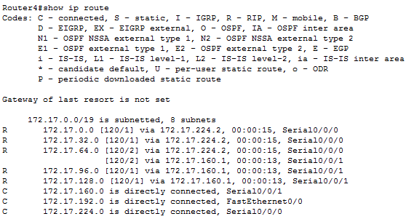

Router OSPF Protocol

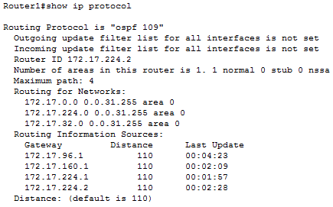

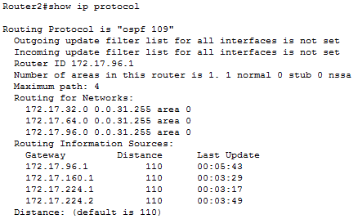

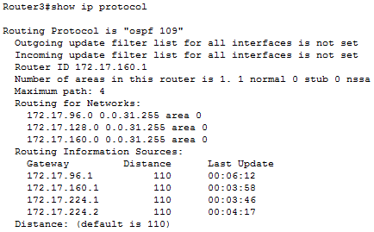

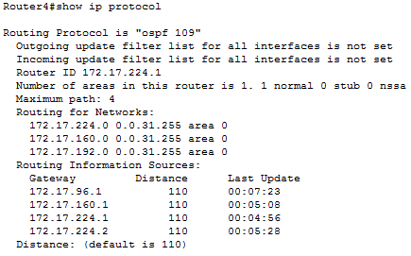

Router OSPF Routing Tables

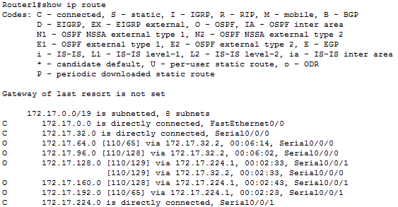

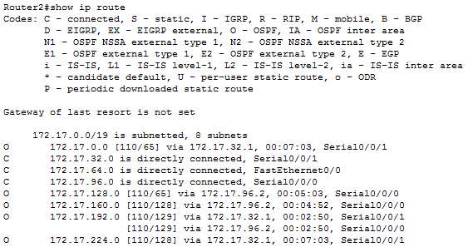

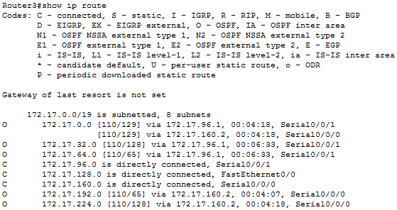

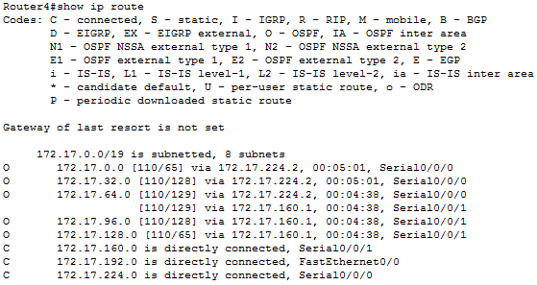

Ping Test (Both Protocols)

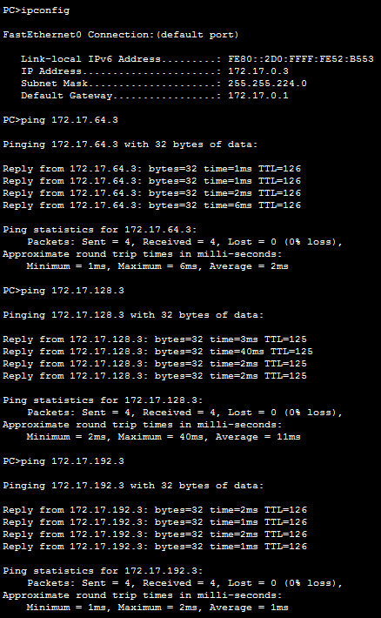

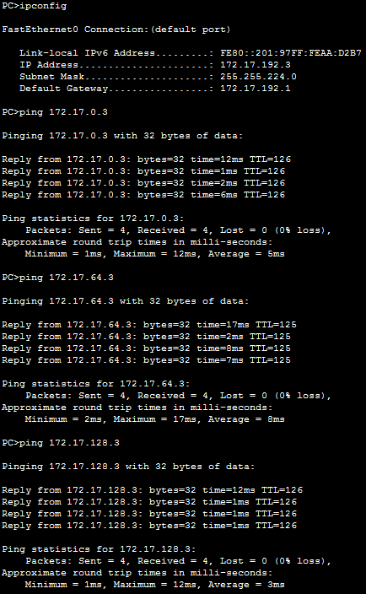

**Results/Outcome**

This lab took relatively less time than the previous lab, due to the fact that all the complex calculations that were present in the previous lab were done for us by the protocols in this lab. I started the topology from scratch as opposed to reworking the previous topology due to the need to manually input “no ip route” statements. Both protocols worked without much difficulty.